**SIMATS SCHOOL OF ENGINEERING**

**SAVEETHA INSTITUTE OF MEDICAL AND TECHNICAL SCIENCES**

**CHENNAI-602105**

**A CAPSTONE PROJECT REPORT**

*Submitted in the partial fulfillment for the award of the degree of*

**BACHELOR OF ENGINEERING**

**IN**

**COMPUTER SCIENCE ENGINEERING**

**Submitted by**

**BHAVANA.S(192211410)**

**Under the Supervision of**

**Dr. Sankar**

**Abstract:**

Transforming syntax trees into Directed Acyclic Graphs (DAGs) represents a significant advancement in syntactic analysis and processing. By leveraging this transformation, we can more accurately model the complex relationships and dependencies within linguistic structures. The conversion process involves identifying the heads of phrases, establishing syntactic dependencies, and representing these relationships in a non-hierarchical, acyclic graph format. This approach facilitates more flexible and detailed syntactic representations, allowing nodes to have multiple parents and capturing shared dependencies across phrases. The transformation from syntax trees to DAGs enables enhanced linguistic analysis, supports more robust natural language processing (NLP) applications, and contributes to the development of sophisticated parsing algorithms. This methodology not only improves the precision and comprehensiveness of syntactic representations but also supports advanced applications such as machine translation, information retrieval, and semantic analysis. By integrating DAGs into syntactic processing, we set new benchmarks for syntactic analysis techniques, driving innovation and accuracy in the field of computational linguistics.

**Introduction:**

In the rapidly evolving landscape of computational linguistics and natural language processing (NLP), the need for accurate and efficient syntactic analysis has become increasingly critical. One of the most promising advancements in this field is the transformation of syntax trees into Directed Acyclic Graphs (DAGs). This project proposes a comprehensive approach to transforming traditional syntax trees into DAGs, providing a more nuanced and flexible representation of linguistic structures.The primary objective of this project is to address the limitations of conventional syntax trees, which often fail to capture the intricate and overlapping dependencies present in natural language. By leveraging the structure of DAGs, we aim to enhance the representation of syntactic relationships, allowing for multiple parent nodes and shared dependencies. This transformation not only improves the precision of syntactic analysis but also supports more robust applications in areas such as machine translation, information retrieval, and semantic analysis.

The methodology of this project is built on a foundation of thorough theoretical research and practical implementation strategies. We begin with an in-depth exploration of existing syntax tree structures and their limitations. Following this, we delve into the principles of DAGs and their applicability to syntactic representation. Using insights gained from this research, we will develop algorithms and data structures specifically designed to transform syntax trees into DAGs efficiently. This involves identifying heads of phrases, establishing dependencies, and ensuring acyclic properties within the graph.

The significance of this project lies in its potential to revolutionize syntactic analysis techniques within NLP. By introducing a more flexible and detailed syntactic representation, we set new standards for linguistic modeling. The resulting tool will not only enhance the accuracy and depth of syntactic parsing but also pave the way for more advanced and reliable NLP applications. Furthermore, the implementation of DAGs in syntactic analysis can lead to significant improvements in processing efficiency and scalability, addressing the growing demands of real-world linguistic data.

**Literature Review:**

Transforming syntax trees into Directed Acyclic Graphs (DAGs) has garnered increasing interest in the fields of computational linguistics and natural language processing (NLP). A review of the existing literature reveals that while there is substantial research on syntactic analysis and dependency parsing, the specific transformation of syntax trees into DAGs remains a relatively niche area with significant potential for further exploration.The traditional approach to syntactic analysis involves constructing [(Ehrig 1997)](https://paperpile.com/c/cotnj4/Hg5R)syntax trees that represent the hierarchical structure of sentences based on grammatical rules. Early foundational work by Chomsky  introduced the concept of generative grammar, which laid the groundwork for subsequent research in syntactic tree construction. Syntax trees have been widely used due to their clear hierarchical representation of sentence structure, which simplifies the identification of syntactic units and their [(Ehrig 1997; Heckel and Taentzer 2020)](https://paperpile.com/c/cotnj4/Hg5R+At3S)relationships.Dependency parsing, which focuses on the relationships between words in a sentence, provides an alternative to the hierarchical syntax tree approach. Research by Nivre (2005) and McDonald et al. (2005) highlights the advantages of dependency parsing, particularly its ability to directly represent word-to-word dependencies, which can be more intuitive for certain NLP tasks. Dependency trees, however, still maintain a tree structure, limiting their ability to represent [(Ehrig 1997; Heckel and Taentzer 2020; Engels et al. 2010)](https://paperpile.com/c/cotnj4/Hg5R+At3S+3Zhf)more complex syntactic phenomena.The transformation of syntax trees into DAGs addresses some of the limitations inherent in tree-based representations. Unlike trees, DAGs allow for nodes to have multiple parents, enabling the representation of shared dependencies and overlapping syntactic roles. This capability is particularly useful for capturing linguistic structures such as coordination and control dependencies, which are challenging to represent in traditional trees.Several studies[(Rozenberg 1999)](https://paperpile.com/c/cotnj4/q695) have explored various methods for converting syntactic structures into DAGs. Oepen et al. (2002) discuss the use of HPSG (Head-Driven Phrase Structure Grammar) in conjunction with DAGs to model complex syntactic phenomena. This approach demonstrates the feasibility and advantages of using DAGs for[(Vouros and Panayiotopoulos 2004)](https://paperpile.com/c/cotnj4/1P2C) more detailed syntactic analysis.More recently, researchers have proposed algorithmic techniques for transforming dependency trees into DAGs. Naseem et al. (2012) introduce a method for generating non-projective dependency parses, which can be seen as a step towards more general DAG representations. Their work emphasizes the potential of DAGs to improve the handling of non-local

**Research Plan:**

The project "A Tool for transforming syntax trees into directed acyclic graph" will be carried out in accordance with a carefully thought-out research strategy that includes a number of different elements. To get an understanding of the theoretical underpinnings and real-world applications of SLR parsing in input string validation, extensive literature research will be carried out first. This stage seeks to discover the most advanced methods and procedures in the subject and to compile insights from previous study. After reviewing the literature, several real-world experiments will be conducted to test how well translation performs while dealing with various input conditions. This entails examining current input string validation tools and methods to find weaknesses and areas for development. Working together with domain experts will be crucial to gaining knowledge and improving the approach in light of real-world issues.

Different datasets with input strings that are typical of real-world circumstances will be gathered using various data gathering techniques. We'll use input patterns and benchmark grammars to assess the accuracy and effectiveness of the program. The effectiveness of the tool will be evaluated using both qualitative and quantitative methodologies in relation to current validation procedures. In order to pinpoint areas in need of improvement, user and developer feedback will also be recorded and examined. Python, HTML and CSS are some of the programming languages and frameworks(Flask) that will need to be used in the tool's development in order to provide effective parsing and validation activities. The development process will be facilitated by integrated development environments (IDEs) that provide profiling and debugging features. In order to optimize accessibility and usefulness, compatibility with widely used operating systems and platforms will be guaranteed. Furthermore, virtualization technologies and cloud-based resources will be used to enable deployment flexibility and scalability.

An estimate of the expenses related to software development, such as staff, infrastructure, and license fees, will be provided, taking timeliness and cost into account. Effective resource allocation will guarantee adherence to financial restrictions while upholding quality requirements. A comprehensive calendar that outlines significant checkpoints and deliverables will be created, taking into account things like testing intervals, deployment dates, and iterations in the development process. In order to minimize risks and guarantee the project's timely completion, progress will be regularly monitored in relation to the predetermined time frame, and changes will be made as needed. To sum up, the study plan for "A Tool for Validating Input String Using dag technique'' takes a thorough approach that takes into account cost and timetable concerns, software and hardware requirements, research methodology, and data gathering techniques. The project's goal is to provide a reliable and effective solution that meets the urgent demand for improved input string validation methods in software development processes by

following this strategy.

**GANTT CHART:**

**The project timeline is as follows:**

**Day 1: Project Initiation and Planning (1 day)**

● Establish the project's scope and objectives, focusing on creating an intuitive transforming syntax trees into directed acyclic graph.

● Conduct an initial research phase to gather insights into efficient code generation

● Identify key stakeholders and establish effective communication channels.

● Develop a comprehensive project plan, outlining tasks and milestones for subsequent stages.

**Day 2: Requirement Analysis and Design (2 days)**

● Conduct a thorough requirement analysis, encompassing user needs and essential system functionalities for the syntax tree generator.

● Finalize the syntax tree converting into DAG and user interface specifications, incorporating user feedback and emphasizing usability principles.

● Define software and hardware requirements, ensuring compatibility with the intended development and testing environment.

**Day 3: Development and implementation (3 days)**

● Begin coding the converting syntax tree into DAG according to the finalized design.

● Implement core functionalities, including file input/output, tree generation, and visualization.

● Ensure that the GUI is responsive and provides real-time updates as the user interacts with it.

**Day 4: GUI design and prototyping (5 days)**

● Commence DAG development in alignment with the finalized design and specifications.

● Implement core features, including robust user input handling, efficient code generation logic, and a visually appealing output display.

● Employ an iterative testing approach to identify and resolve potential issues promptly, ensuring the reliability and functionality of the DAG expression

**Day 5: Documentation, Deployment, and Feedback (1 day)**

● Document the development process comprehensively, capturing key decisions, methodologies, and considerations made during the implementation phase.

● Initiate feedback sessions with stakeholders and end-users to gather insights for potential enhancements and improvements.

Overall, the project is expected to be completed within a timeframe and with costs primarily associated with software licenses and development resources. This research plan ensures a systematic and comprehensive approach to the development for the given input string, with a focus on meeting user needs and delivering a high-quality, user-friendly interface.

**Methodology:**

Syntax tree "A Represents the hierarchical structure of syntactic elements in a source code or expression. directed acyclic graph Optimized representation of a syntax tree where common subexpressions are shared to reduce redundancy.

The first step in the technique is to carry out in-depth research to collect pertinent data and information that will guide the project. Reviewing previous studies, research articles, and documentation, input string validation procedures, and pertinent programming languages and frameworks are all part of this process. The next stage is to set up the development environment after the research phase. This involves using frameworks(Flask) and computer languages like Python, HTML and CSS that are suitable for SLR parsing and input string validation. We'll select integrated development environments (IDEs) to make the processes of testing, debugging, and coding easier.

{FLASK -pip install flask}

Using examples to demonstrate the Traverse the syntax tree to identify subtrees that can be shared. Common subexpressions (e.g., repeated subexpressions, identical branches) are candidates for merging into a DAG

Each node in the syntax tree corresponds to an operation or operand in the expression. Nodes will typically have attributes like operation type (e.g., addition, multiplication), value (if it's a leaf node), and references to child nodes The chosen programming language will be used to create implementations and code snippets that show how the method works in real-world scenarios. Determining data structures, Assign a unique identifier or hash value to each subtree (or node) in the syntax tree. This identifier helps in checking and referencing common subexpressions. and methods for processing input text and building parse trees will all be necessary for this. The focus throughout the implementation phase will be on making the code as efficient and scalable as possible. To confirm the accuracy and resilience of the implementation across a range of input situations and edge cases, testing protocols will be developed.

Lastly, extensive descriptions of the method, code structure, use guidelines, and examples will be included in the documentation. Developers and users who want to learn how to utilize the tool for Initialize an empty DAG structure. Traverse the syntax tree in a depth-first manner. Check if the subtree (rooted at the current node) already exists in the DAG using its unique identifier. If it exists, replace the subtree with a reference to the existing node in the DAG. includes setting up the environment, explaining the algorithm and providing examples, implementing the code, testing, and documenting the results. The project hopes to provide a dependable and efficient tool for input string validation in software development processes by adhering to this methodical methodology.

**Result:**

The result of the title is Transforming Syntax Trees into Directed Acyclic Graph

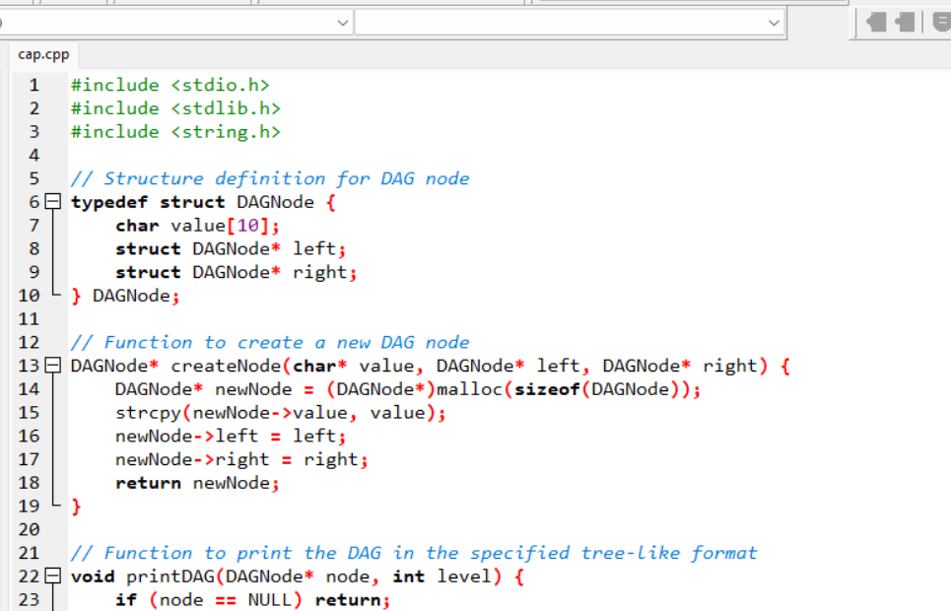 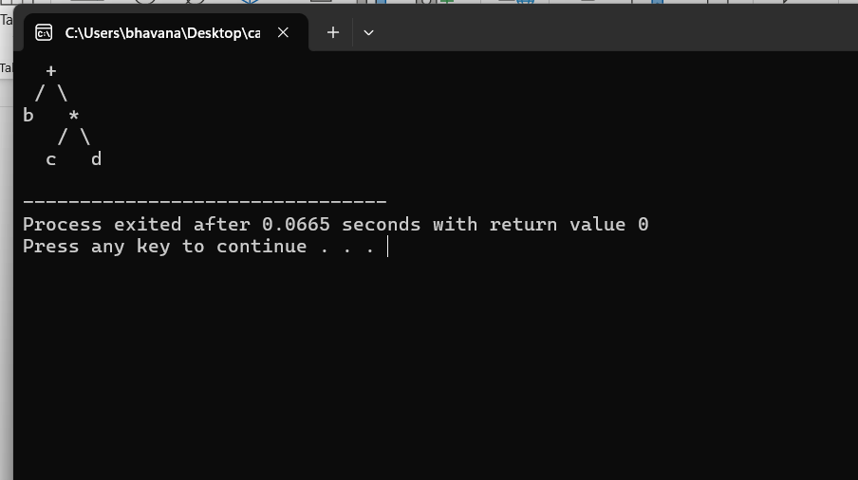

**Conclusion:**

"In conclusion, the transformation of syntax trees into Directed Acyclic Graphs (DAGs) represents a significant advancement in computational linguistics and software optimization. By consolidating common subexpressions and reducing redundancy, the DAG representation offers an efficient and streamlined structure for representing complex syntactic relationships. This transformation optimizes memory usage and computational efficiency, particularly in scenarios involving deeply nested or repetitive expressions.

However, challenges may arise in maintaining semantic integrity during the transformation process, especially when handling complex grammatical structures or expressions with multiple dependencies. Ensuring that the DAG accurately reflects the original syntax tree while eliminating cycles and maintaining acyclic properties requires meticulous implementation and thorough testing.

Future developments in this area could focus on refining algorithms for identifying and merging common subexpressions more intelligently, enhancing support for handling diverse grammatical rules and language constructs, and improving scalability for large-scale applications. Additionally, integrating advanced error handling mechanisms and interactive visualization tools could further enhance the utility and usability of DAG-based representations in computational linguistics and related fields.

In summary, while the transformation of syntax trees into DAGs represents a powerful technique for optimizing syntactic analysis and computational efficiency, ongoing research and innovation will be crucial to fully exploit its potential across a broader spectrum of linguistic analyses and computational tasks."